“Lets make Whoopie” Pies by Sian Hindle

Following on from Cupcakes, the latest craze from America is terms of cake and sweet treats is Whoopie Pie... The cupcake craze swept the whole of Britain with the humble cupcake becoming the height of fashion. In London, there are whole shops dedicated to cupcakes of all varieties and flavours. According to cake fashionistas, the whoopie pie is set to take on the mantle in the future.

So what is it ? Whoopie Pie looks like a giant Oreo cookie and is two mound shaped chocolate cakes, sandwiched together with a creamy mashmallow filling.

The history of Whoopie Pie is very interesting, traced back to New England, the Pie is an Amish Tradition. Apparently, Amish women would make the pies and pack them into their families lunchboxes. When the husbands, and children opened their box, if they found a sweet treat, they would shout “Whoopie !”

Whoopie Pies are about as big as a hamburger and are best eaten with a glass of milk. They consist of 2 soft chocolate cookies made with vegetable shortening, not butter, then filled with “Marshmallow Fluff” (which is available in supermarkets, on the jams aisle.)

How to Make Whoopie Pies
Ingredients
125g solid vegetable shortening eg. Trex
225g brown sugar
1 egg
50g cocoa
450g Plain flour
1 tsp baking powder
1 tsp baking soda
1 tsp salt
1 tsp vanilla extract
225ml milk
Whoopie Pie Filling (see recipe below)
1) Preheat oven to 180 ‘c/ 160’c Fan/Gas 4. Lightly grease baking sheets.
2) In a large bowl, cream together shortening, sugar, and egg. In another bowl, combine cocoa, flour, baking powder, baking soda, and salt.
3) In a small bowl, stir the vanilla extract into the milk. Add the dry ingredients to the shortening mixture, alternating with the milk mixture; beating until smooth.
4) Drop batter* (to make 18 cakes) onto prepared baking sheets. With the back of a spoon spread batter into 4-inch circles, leaving approximately 2 inches between each cake. Bake 15 minutes or until they are firm to the touch. Remove from oven and let cool completely on a wire rack. (*May be easier to pipe with piping bag.)
5) Make Whoopie Pie Filling. When the cakes are completely cool, spread the flat side (bottom) of one chocolate cake with a generous amount of filling. Top with another cake, pressing down gently to distribute the filling evenly. Repeat with all cookies to make 9 pies. Wrap whoopie pies individually in plastic wrap, or place them in a single layer on a platter (do not stack them, as they tend to stick).
Makes 9 large whoopie pies.
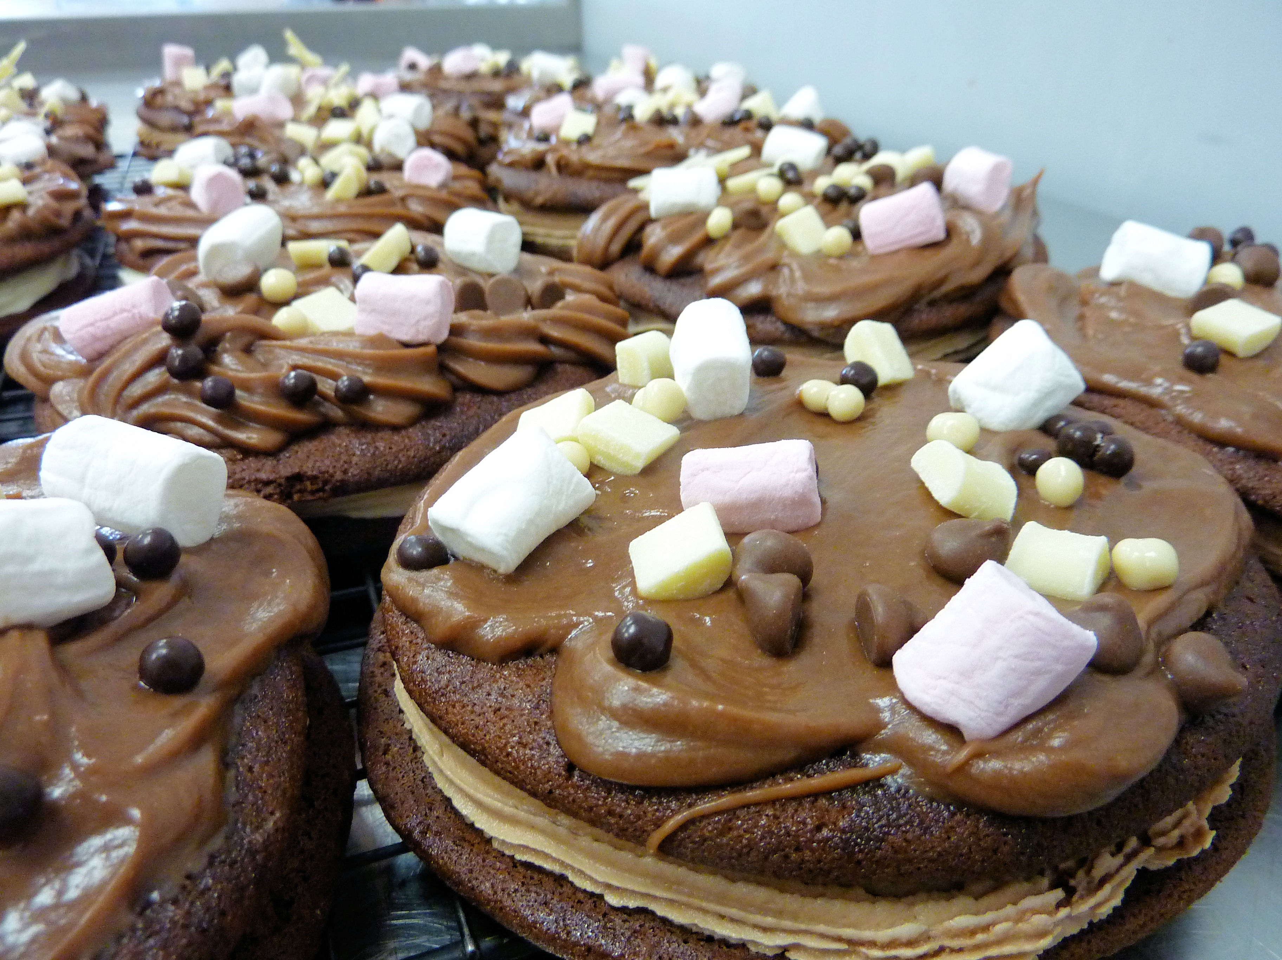

Whoopie Pie Filling:
225g Trex
350g Icing sugar
450g Marshmallow Fluff**
1 ½ tsp vanilla extract
*Butter may be substituted for all or part of the vegetable shortening, although traditional Whoopie Pies are made with vegetable shortening only
** Marshmallow Creme may be substituted.
1) In a bowl, beat together shortening, sugar, and Marshmallow fluff; stir in vanilla extract until well blended.

Check out our blog site to watch Sian making Whoopie Pies.... www.lacreme.typepad.co.uk

