La Parrilla Desserts
menu
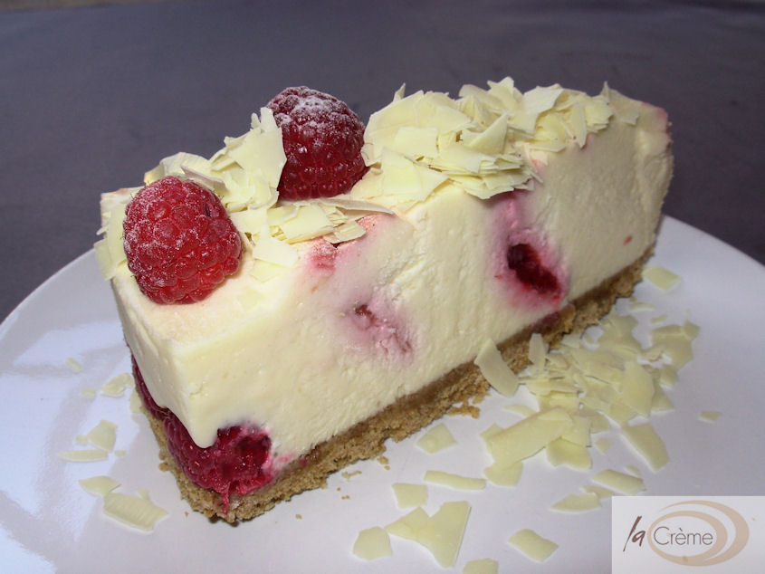
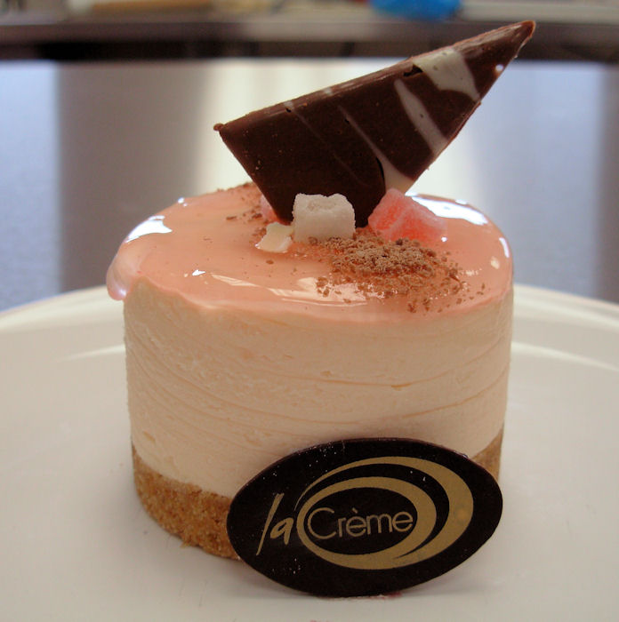
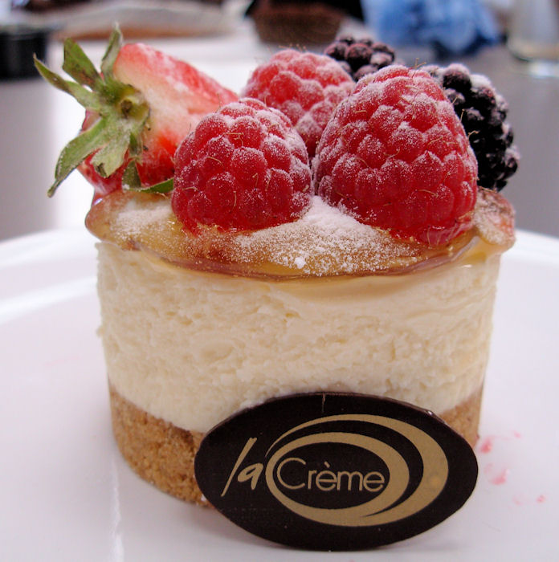

Turkish Delight Cheesecake

Biscuit base with rose flavoured cheesecake. Topped with rose gel and decorated with chocolate and pieces of Turkish delight.

Passionfruit Cheesecake

Biscuit base with vanilla cheesecake, topped with passionfruit gel and fresh fruit decoration.

White Chocolate & Raspberry Ripple Cheesecake

Biscuit base with vanilla cheesecake, rippled with raspberry coulis, decorated with white chocolate shavings and fresh raspberries.

Baked Cheesecake with Vodka soaked raisins and Rhubarb

Baked vanilla cheesecake, speckled with raisins soaked in vodka and topped with rhubarb and vodka gel.

Mocha Pannacotta

Segafredo coffee pannacotta over a chocolate sauce, served with a biscuit.

Carmel & Hazelnut Mousse Gateau

Caramel mousse encased in sponge, topped with hazelnut whipped cream and sprinkled with hazelnuts.

Chocolate Brownies (v)

77% cocoa solids, dense and dark brownies served with ice cream.

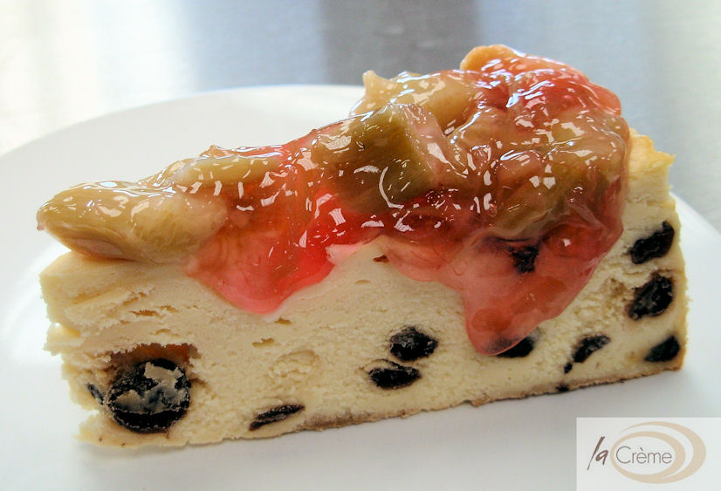
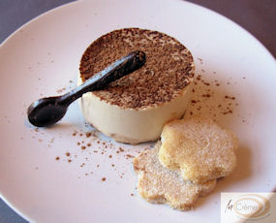
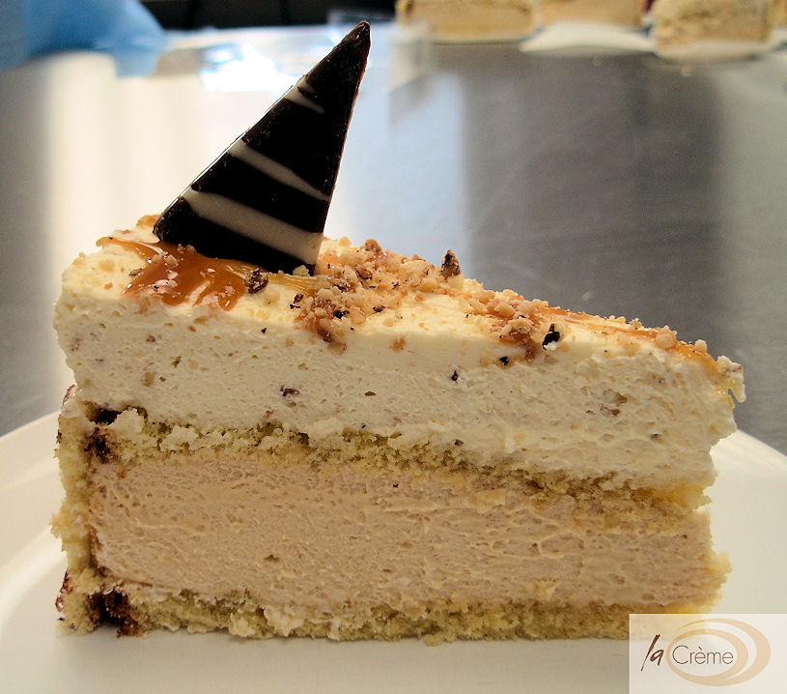

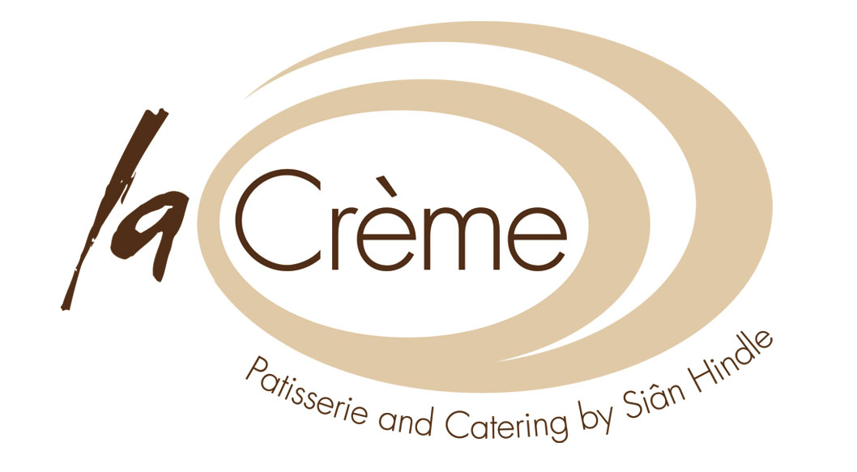
Desserts supplied by La Crème Patisserie, Angel Street, Neath
Tel 01639 638574 www.lacreme.typepad.co.uk

